2A.
In the packet list pane, select the first DNS packet. In the packet detail pane, select the
User Datagram Protocol. The UDP hexdump will be highlighted in the packet byte lane.
Using the hexdump,Answer the following:
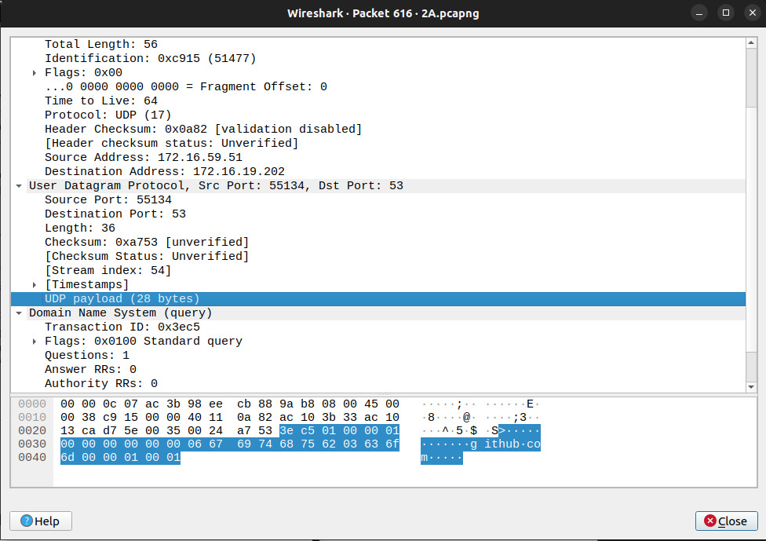
a. the source port number
Ans : 55134

b. the destination port number
Ans : 53

c. the total length of the user datagram
Ans : 36

d. the length of the data
Ans : 28 – 8 = 20

e. whether the packet is directed from a client to a server or vice versa
Ans : source address = 172.16.59.51
client address = 172.16.19.202

The packet is directed from a client to a server.

f. the application-layer protocol.
Ans : User Datagram Protocol

g. whether a checksum is calculated for this packet or not.
Ans : Calculated Value = 0xa753
2B. What are the source and destination IP addresses in the DNS query message? What are those
addresses in the response message? What is the relationship between the two?
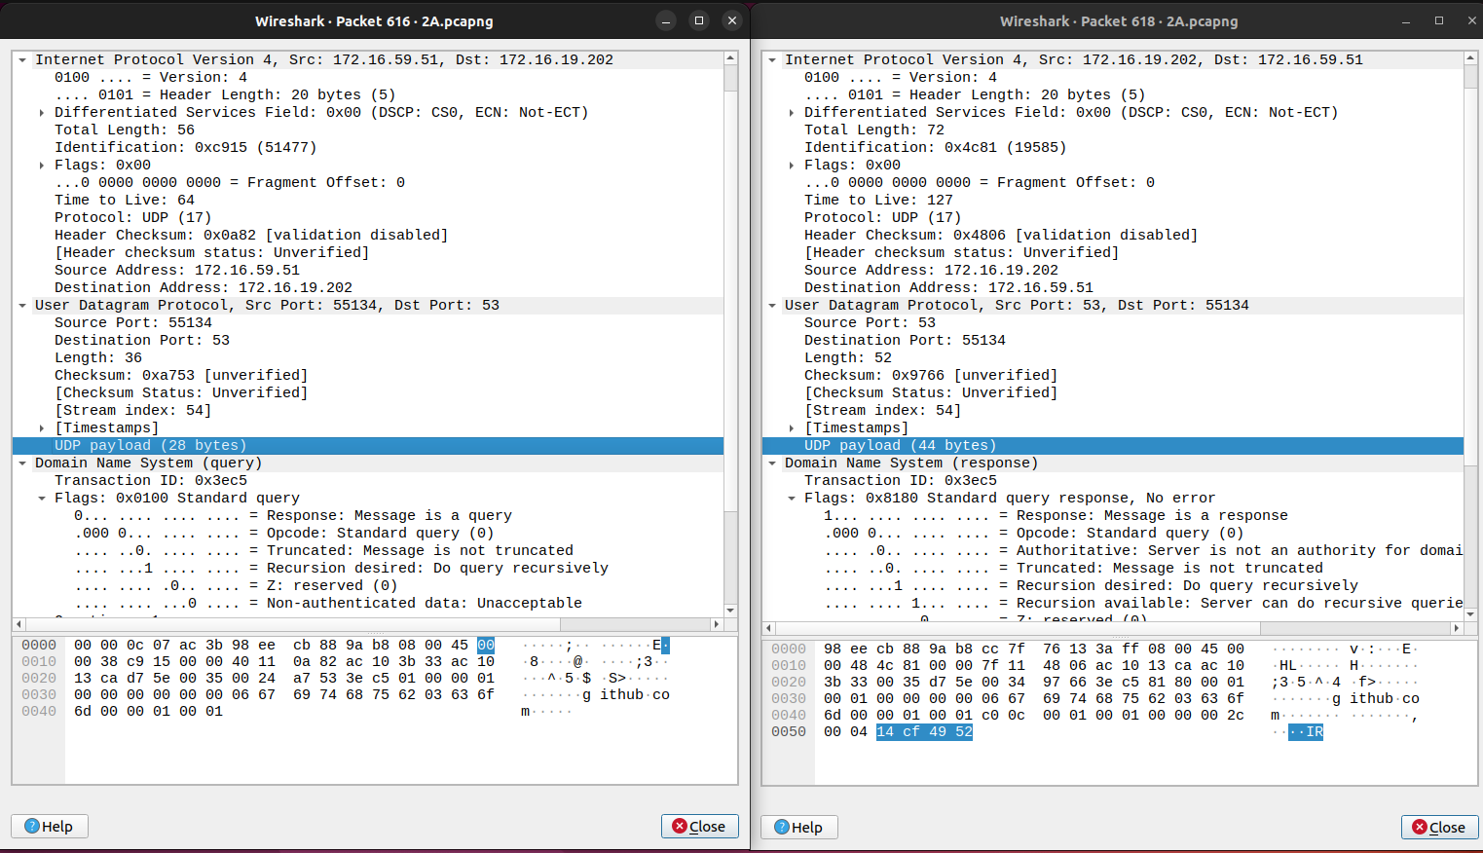

Left Image : DNS Query
Right Image : DNS Response

Query
Source Address : 172.16.59.51
Destination Address : 172.16.19.202

Response
Source Address : 172.16.19.202
Destination Address : 172.16.59.51

Query is sent from Client to Server where as Response is ViceVerca.
2C. What are the source and destination port numbers in the query message? What are those
addresses in the response message? What is the relationship between the two? Which port
number is a well-known port number?
Left Image : DNS Query
Right Image : DNS Response

Query
Source Port : 55134
Destination Port : 53

Response
Source Port : 53
Destination Port : 55134

Query is sent from Client to Server where as Response is ViceVerca.

Well Known Port for DNS is 53
2D. What is the length of the first packet? How many bytes of payload are carried by the first
packet?
Length = 36

Payload = 28 bytes

